[**DIGITAL SIGNAL & IMAGE PROCESSING LAB**](https://github.com/Amey-Thakur/DIGITAL-SIGNAL-AND-IMAGE-PROCESSING-AND-DIGITAL-SIGNAL-AND-IMAGE-PROCESSING-LAB)

[**EXPERIMENT -**](https://github.com/Amey-Thakur/DIGITAL-SIGNAL-AND-IMAGE-PROCESSING-LAB) **3**

**PART B**

(PART B: TO BE COMPLETED BY STUDENTS)

***(Students must submit the soft copy as per the following segments within two hours of the practical. The soft copy must be uploaded on the Blackboard or emailed to the concerned lab in charge faculties at the end of the practical in case there is no Blackboard access available)***

| **Roll No. 50** | **Name: AMEY THAKUR** |
| --- | --- |
| **Class: COMPS-BE-B-50** | **Batch: B3** |
| **Date of Experiment: 11/08/2021** | **Date of Submission: 11/08/2021** |
| **Grade :** |  |

**A.1 Aim:**

Write a program to perform the mathematical operation Discrete Correlation and measure the degree of similarity between two signals.

**B.1 Software Code written by student:**

***(Paste your code completed during the 2 hours of practical in the lab here)***

1. **Cross-Correlation**

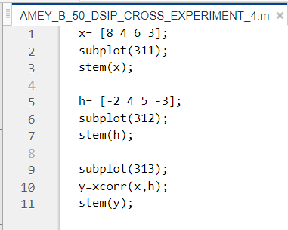

1. **Auto-Correlation**

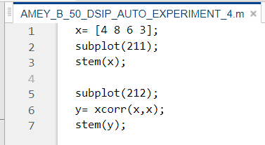

**B.2 Input and Output:**

1. **Cross-Correlation**

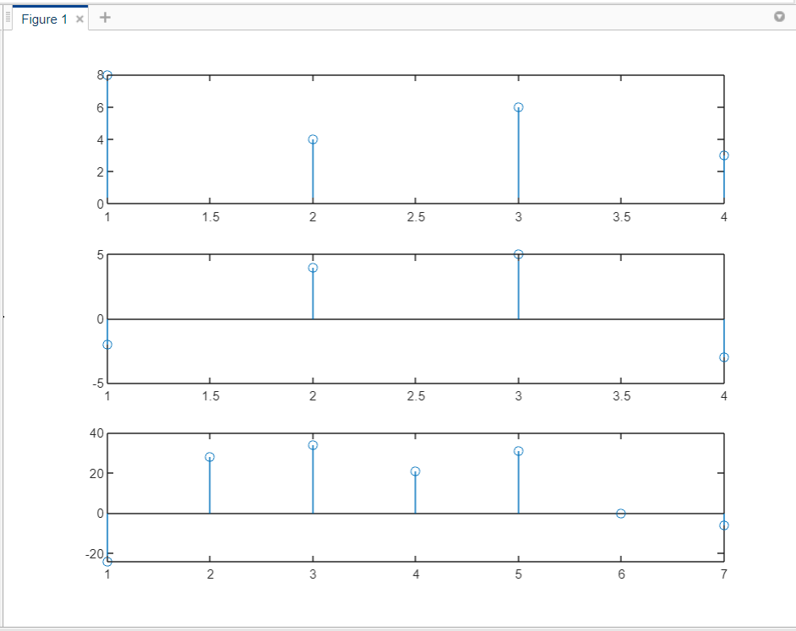

1. **Auto-Correlation**

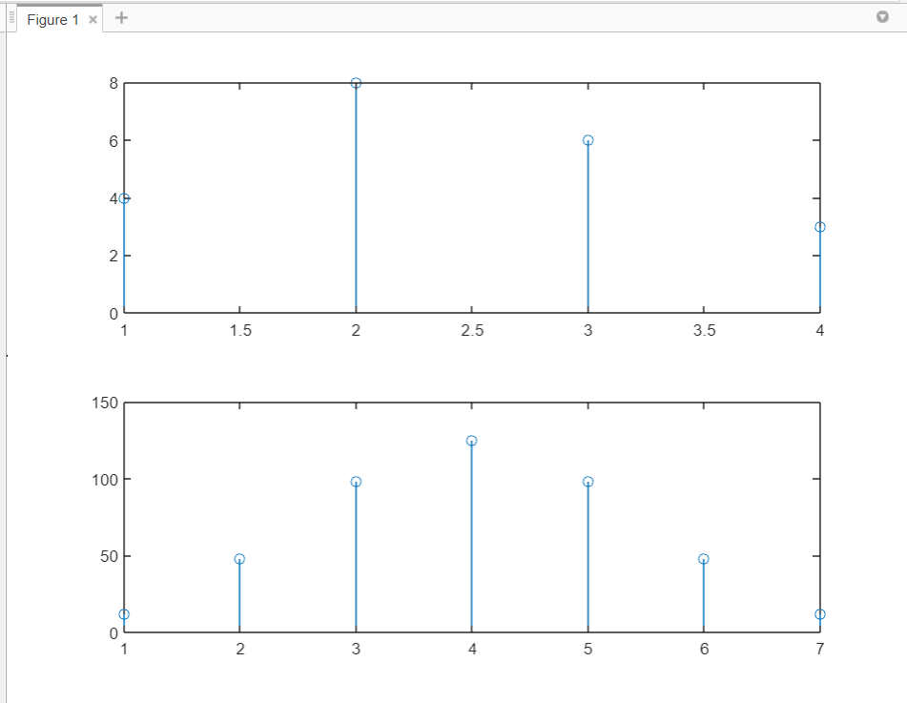

**B.3 Observations and learning:**

***(Students are expected to comment on the output obtained with clear observations and learning for each task/ sub part assigned)***

We measured the similarity between two signals and compared them. We used MATLAB to code and plot the autocorrelation and cross correlation graphs and compared them.

**B.4 Conclusion:**

***(Students must write the conclusion as per the attainment of individual outcome listed above and learning/observation noted in section B.3)***

Hence we’ve successfully implemented and understood the concepts of Discrete Correlation like Cross and Auto Correlations using MATLAB.

**B.3 Question of Curiosity:**

***(Write appropriate answers in your own words.)***

1. What is the difference between convolution and correlation?

Ans:

Convolution is a mathematical method of combining two signals to form a third signal. The characteristics of a linear system are completely specified by the impulse response of the system and the mathematics of convolution.1 It is well-known that the output of a linear time (or space) invariant system can be expressed as a convolution between the input signal and the system impulse response function. Convolution is the basis for many signal processing techniques. For example, digital filters are synthesized by designing appropriate impulse response functions. Targets are detected on the radar by analyzing the measured impulse responses.

Correlation is a simple mathematical operation to compare two signals. Correlation is also a convolution operation between two signals. But there is a basic difference. The correlation of two signals is the convolution between one signal with the functional inverse version of the other signal. The resultant signal is called the cross-correlation of the two input signals. The amplitude of the cross-correlation signal is a measure of how much the received signal resembles the target signal. The correlation peak specifies the location of the target. Correlation operation is regularly done in radar communication.

1. What is the difference between autocorrelation and cross correlation?

Ans:

Cross-correlation: is the degree of similarity between two-time series in different times or space while lag can be considered when time is under investigation. The difference between these two time series in different situations like distance, angle, direction, etc.

can be considered while the space is under investigation respectively. Auto-correlation: is the cross-correlation of a time series while investigating the persistence between lagged times of the same time series or signal.